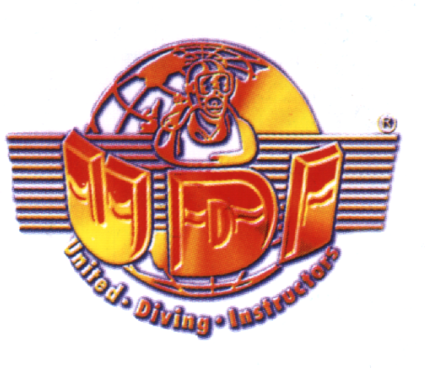

United – Diving - Instructors

Training Guidelines

Introductory diving

Youth snorkelers

Junior Diver * / Junior Diver * * / Junior Diver * * *

Pool Diver / Basic Diver / Open Water Diver *

Advanced Open Water Diver * *

Special Diver * * *

Status: 2022

Introductory diving
The entry with the DTG into the natural sport of diving. The participant should experience an easy dive positively. After this dive, he should be interested in recreational diving if possible.

From 8 years

Youth snorkelers

The entry for our youngest to have fun with the ABC equipment
and to be safe in handling the equipment.

From 6 years

Junior Diver 1 *

The entry point for our youngest to have fun with scuba diving
and to be safe in handling the equipment.
Up to a maximum of 3m diving depth

From 8 years

Junior Diver 2 **

For our youngest to deepen and consolidate the scuba diving in order to gain more safety in the handling of the equipment.
Up to a maximum of 5m diving depth

From 9 years

Junior Diver 3 ***
The entry into scuba diving in the pool or in the shallow water area to with the
Instructor or with the legal guardian (with diving license) to experience smaller dives.
Up to a maximum of 10m diving depth

From 10 years

Pool Diver

This level is the prerequisite for the Basic Diver and Open Water Diver*.

Here the basic knowledge in practice and theory is imparted.
In addition, this stage is a very good preparation for the following open water dives to the Basic Diver or Open Water Diver*.

From 12 years

Basic Diver

This level is for the Open Water Diver and is understood as an intermediate step to the diver*, whereby the Basic Diver after certification to the diver*

is also certified. Training 2 practical dives.

From 12 years

Open Water Diver *

Prerequisite:
Pool Diver or Basic Diver

The training includes the minimum number of six open waterdives, which build on the performance level of the Pool Divers / Basic Divers, complement it and increase safety. The theory and practice are further deepened and concluded with a theory test.
A maximum of three dives may be completed per dive day.
diving depth 18m

from 14 years

Advanced Open Water Diver * *

Prerequisite:

Min. 20 dives to O W D * at a depth of 10 - 18 meters

Special seminars:

CPR not older than two yearse, water rescue - Rescue

recommended is night diving, drift diving , wreck diving, diving technique

The training includes the minimum number of six open waterdives and a theory test. In the training, special emphasis is placed on safety, leading dives and their careful planning. Furthermore, the important aspect of environmentally friendly diving is also on the training program.
A maximum of three dives may be completed per dive day.

from 16 years

Master Diver * * *

Prerequisite:
Minimum 40 dives according to A O W D * * in mindestens 10 - 40 meters depth (10 TG of which deeper than 30 m) in salt or 30 meters in fresh water depth

Special seminars:
Deep Diver, Water Rescue and
Night diving, CPR not older than two yearse.
Recommended: Diving technique, dry, current, boat, wreck diving or diving in sea caves.

The training includes the minimum number of six open water dives and a theory and a practical test. The diver should deepen and expand his safety in theory and practice in the various specialist areas and demonstrate the implementation in such a practical way that the dives can be carried out safely.
A maximum of three dives may be completed per dive day.

from 18years

